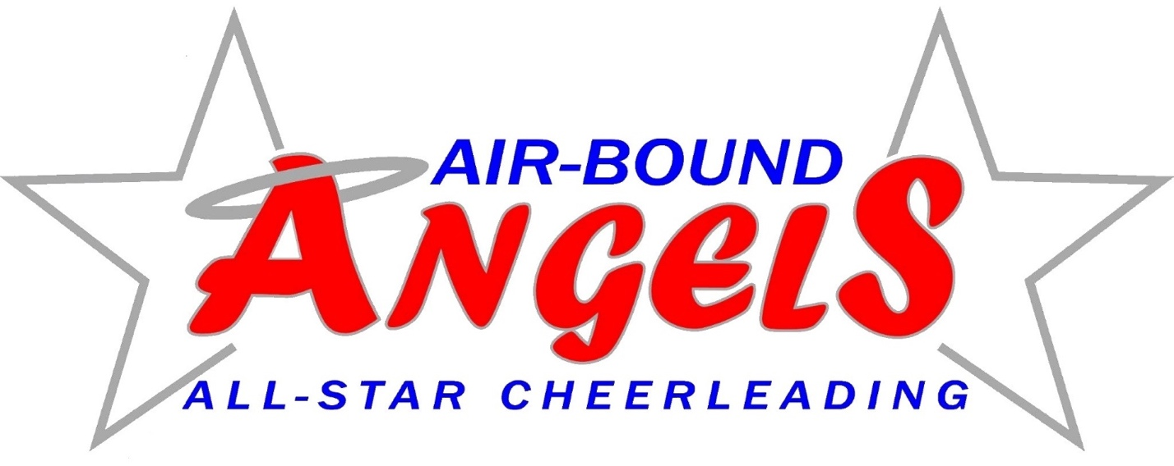
SPONSOR FORM
($75 minimum)

BUSINESS NAME: _______________________________________________

CHEERLEADER NAME: ___________________________________________

DO YOU NEED A RECEIPT? YES NO

